**Project View:**

Some Screenshots of this project are given below

**Home Page:** [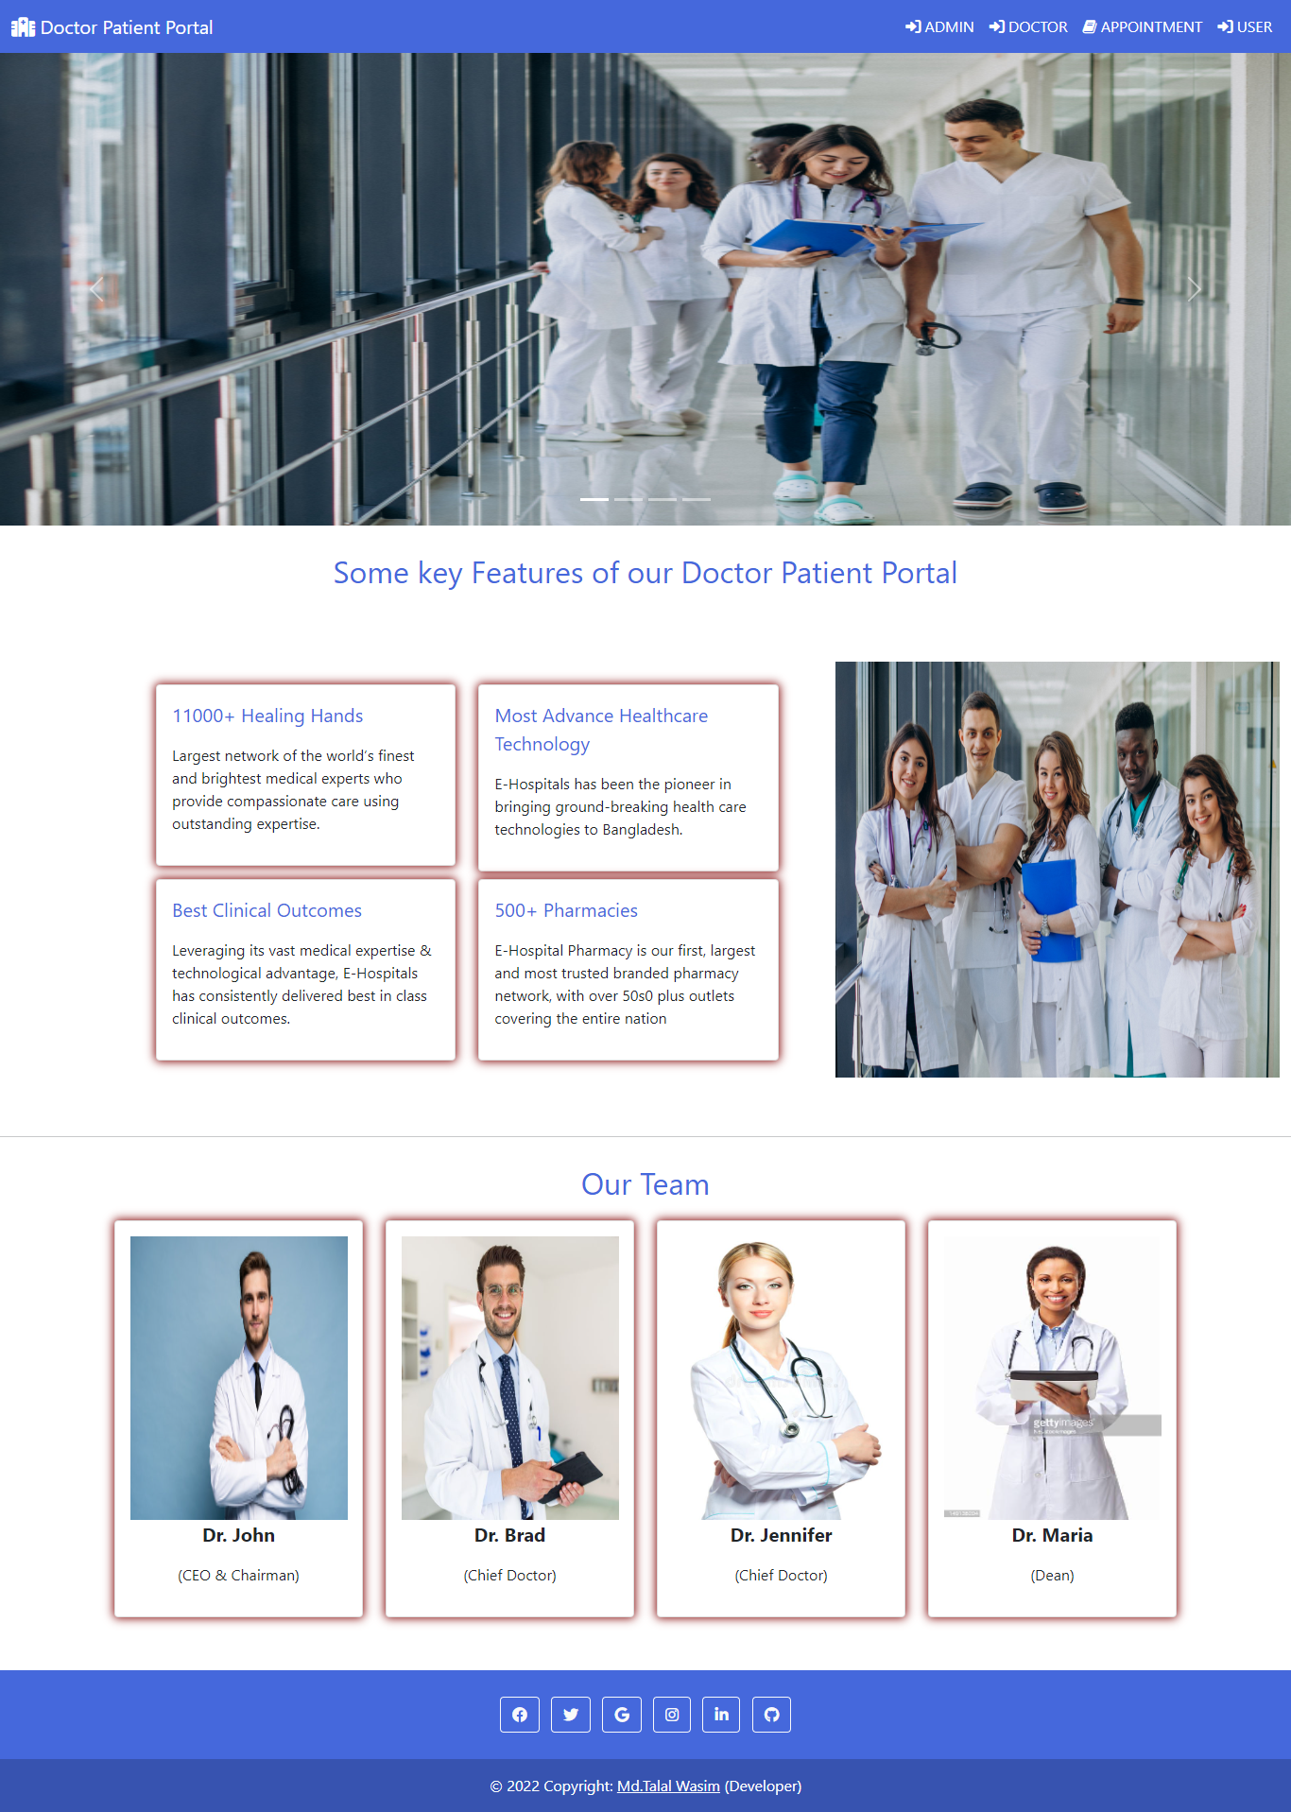](https://user-images.githubusercontent.com/91146041/205282972-18a37392-538a-477a-8fb5-c28636b666c4.png)

[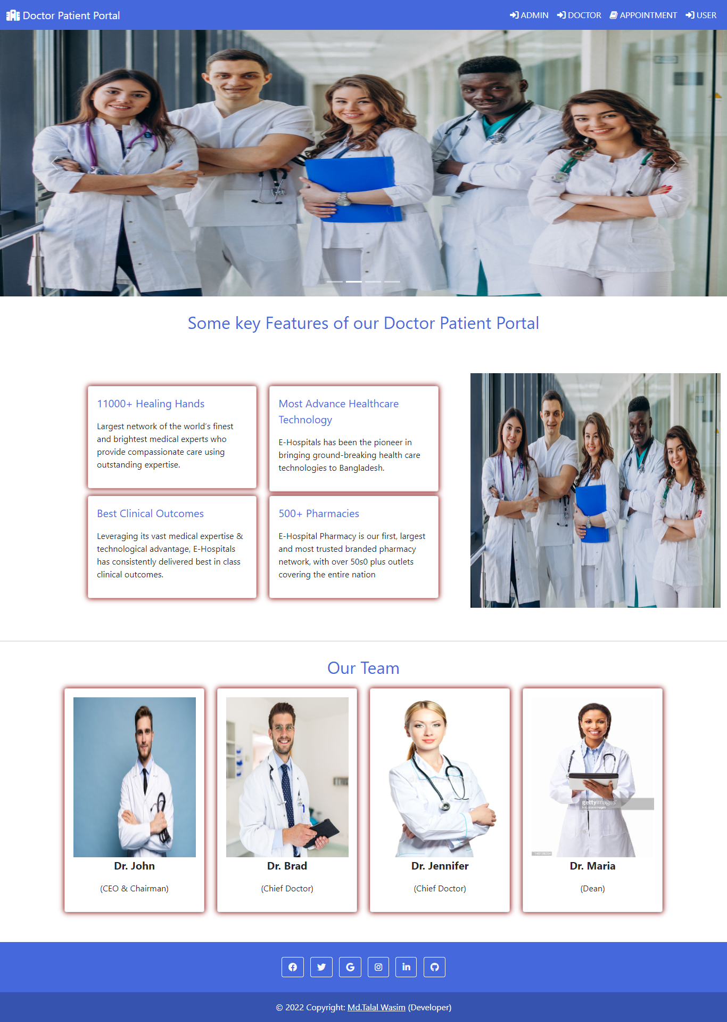](https://user-images.githubusercontent.com/91146041/205282986-f5efe4b3-abf6-4059-bb98-50788f8142c7.png)

**Admin Login:**

[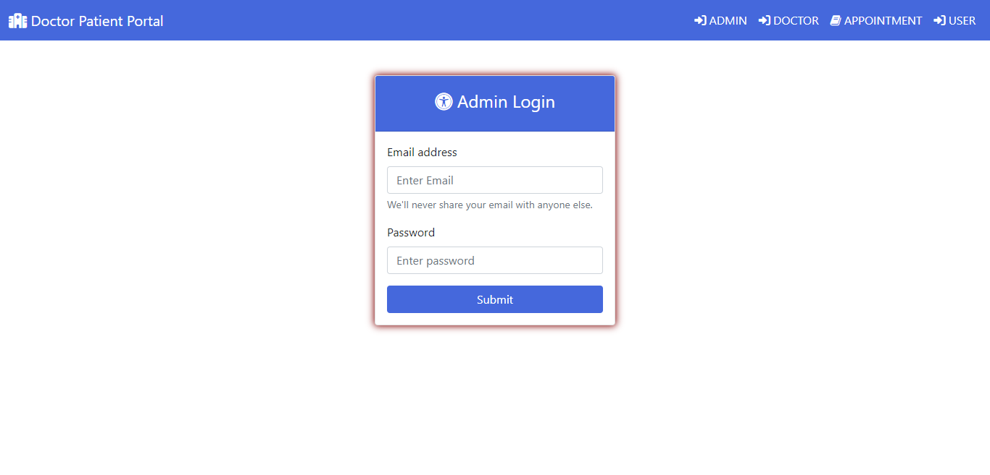](https://user-images.githubusercontent.com/91146041/205282991-aa2add0e-4442-4041-8535-686f324300fa.png)

**Admin Dashboard:**

[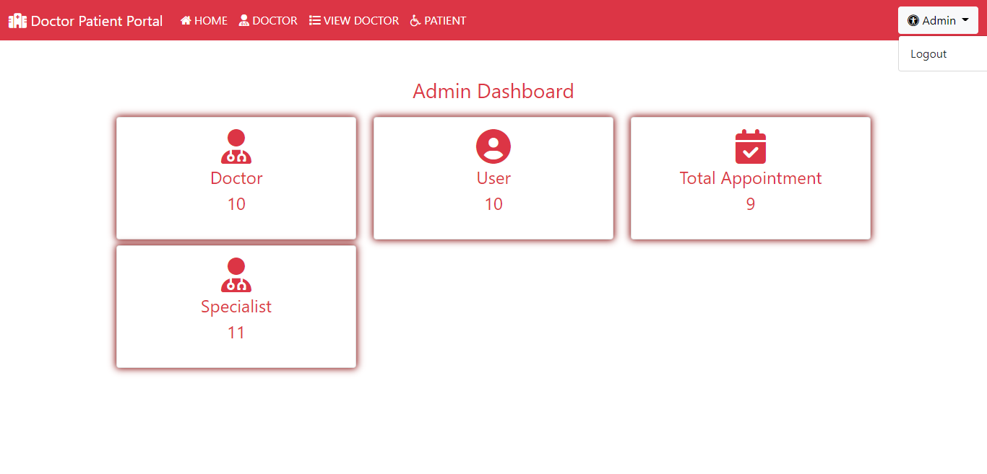](https://user-images.githubusercontent.com/91146041/205282994-08164397-981f-49ed-b492-a5e75a0c58e4.png)

**Add Specialist:**

[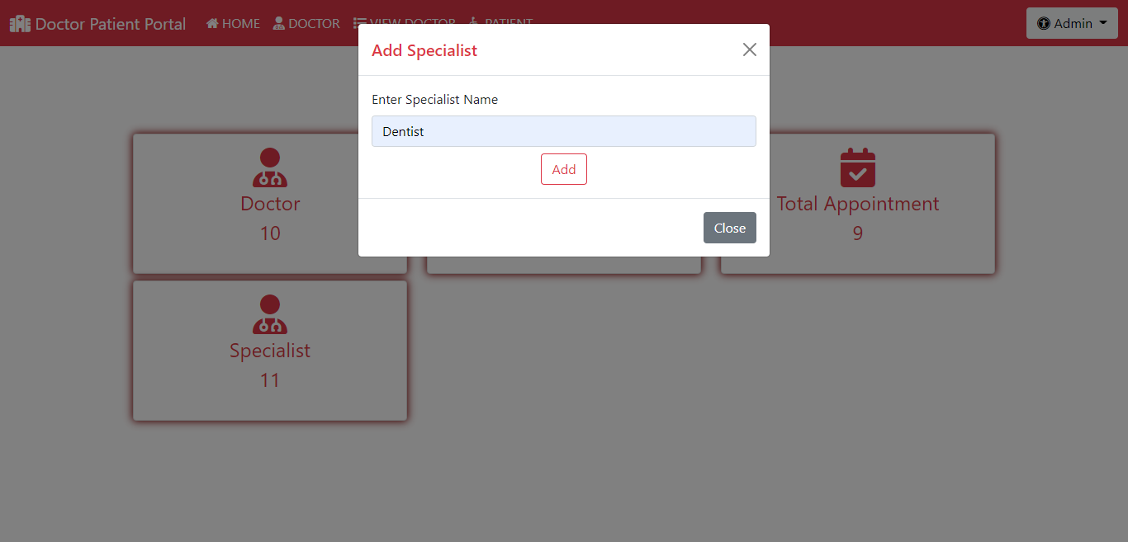](https://user-images.githubusercontent.com/91146041/205282996-09b1a30c-4919-4336-9b3e-45953b9c9d51.png)

**Add Doctor:**

[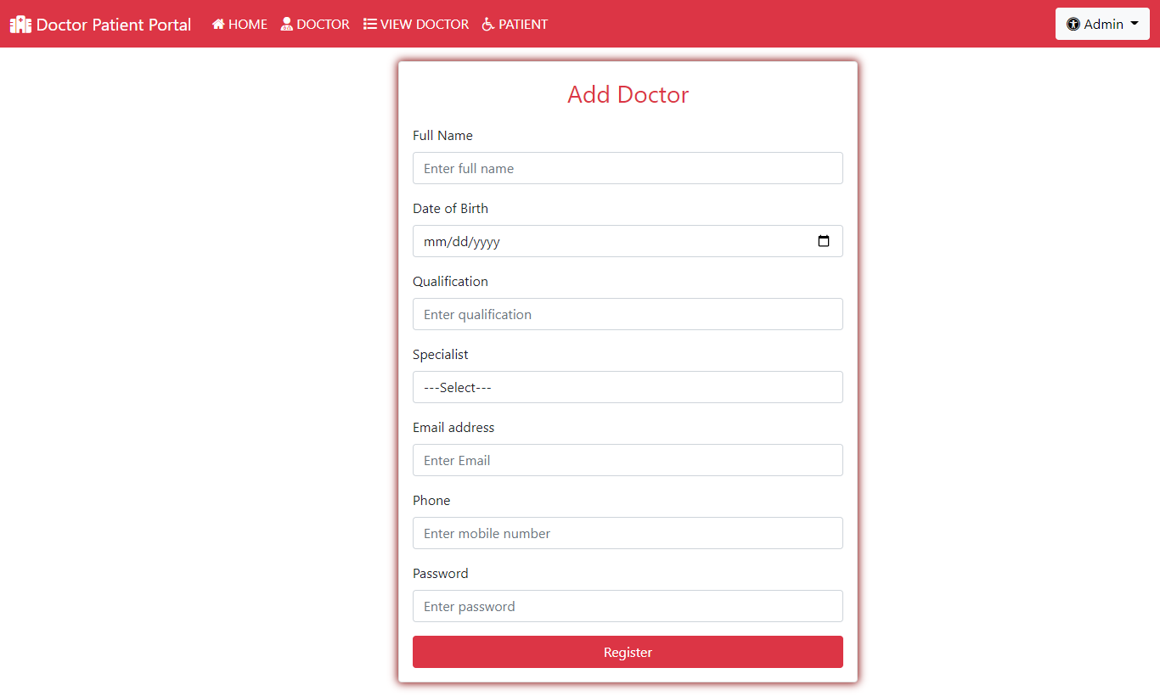](https://user-images.githubusercontent.com/91146041/205283000-92b9b560-2a3a-4f01-82d2-ad313e1a7653.png)

**Doctor List:**

[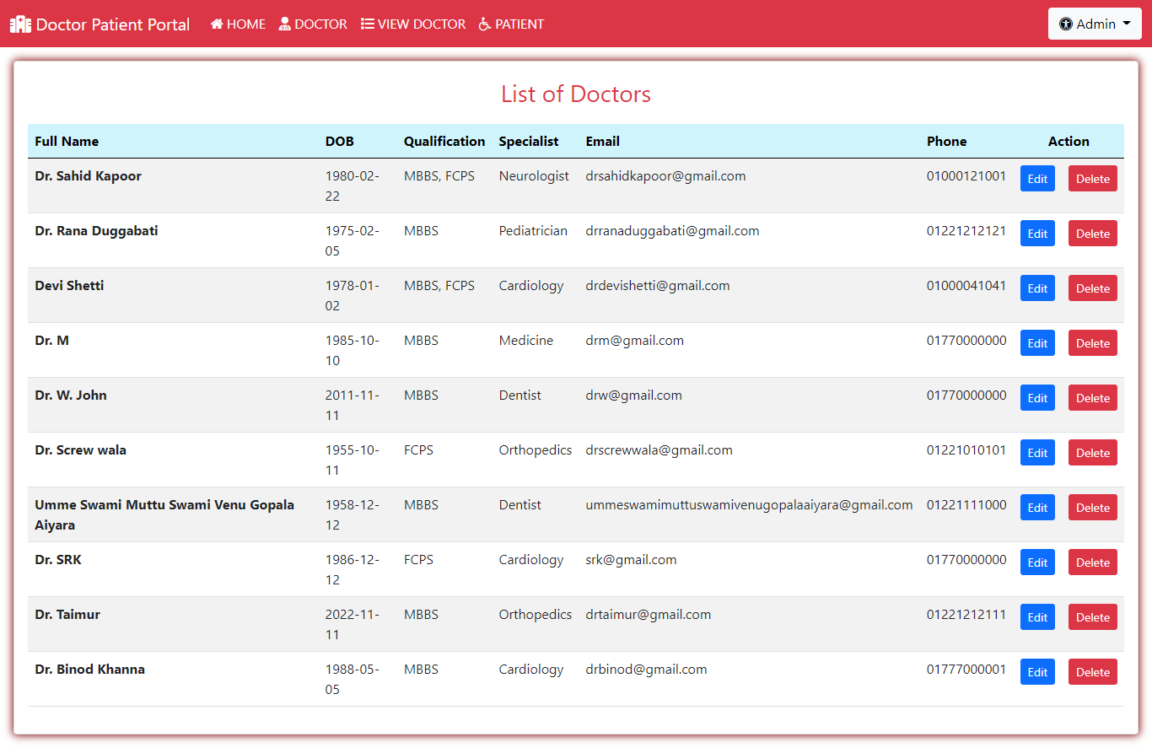](https://user-images.githubusercontent.com/91146041/205283003-45e45a28-722d-4ffd-b762-d116335e9789.png)

**No. of Patients Appointment:**

[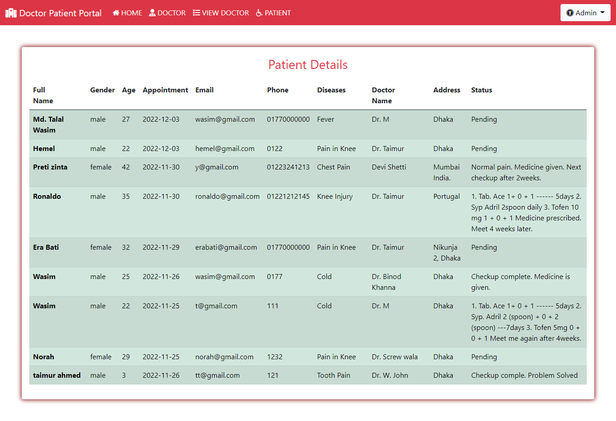](https://user-images.githubusercontent.com/91146041/205283006-93c834b1-1f88-4ba9-9e50-7cf54f15661b.png)

**Doctor Login:**

[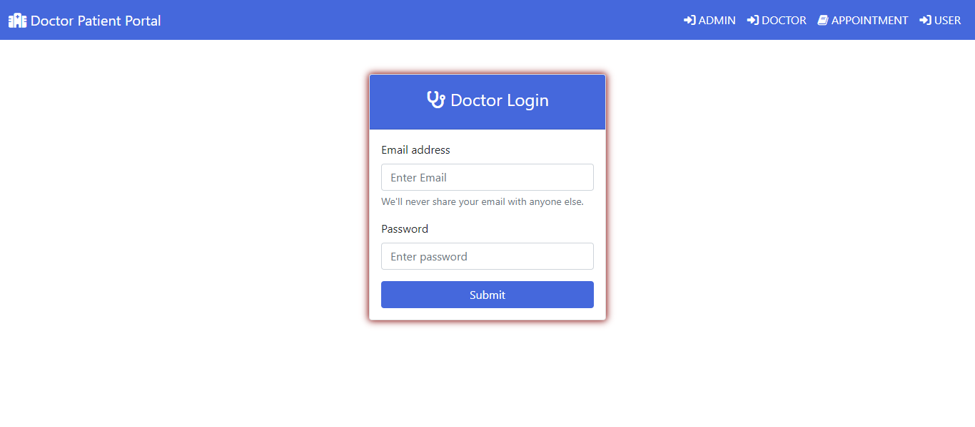](https://user-images.githubusercontent.com/91146041/205283010-3b80f5a6-2a12-46cb-abf5-23c8131f2115.png)

**Doctor Dashboard:**

[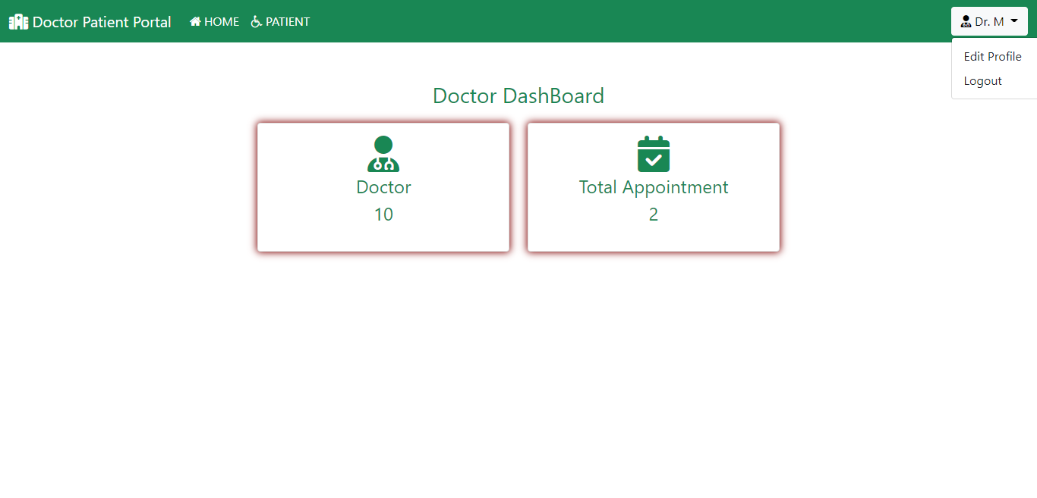](https://user-images.githubusercontent.com/91146041/205283016-902df9d7-eb76-41f0-9e11-7e2b46390b99.png)

**View list of Patient Appointment:**

[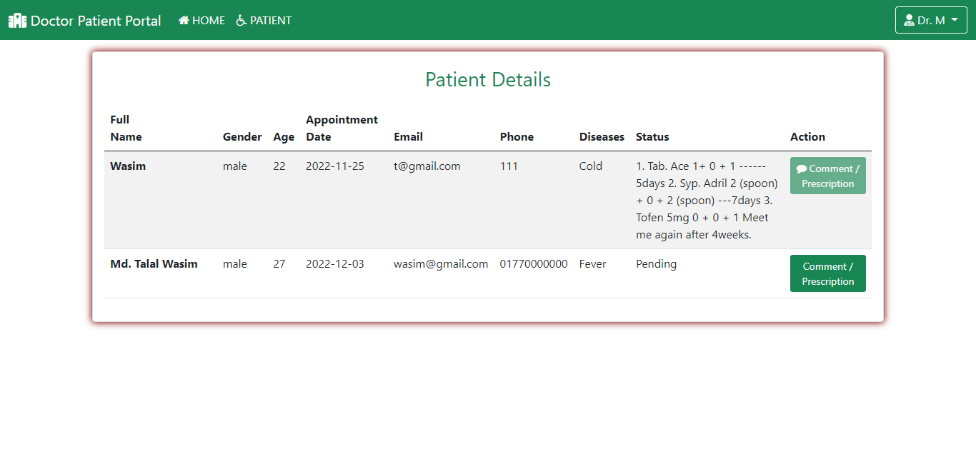](https://user-images.githubusercontent.com/91146041/205283019-fa94c37e-9a82-4195-8724-891d7465ed38.png)

**Edit/Change Profile Details:**

[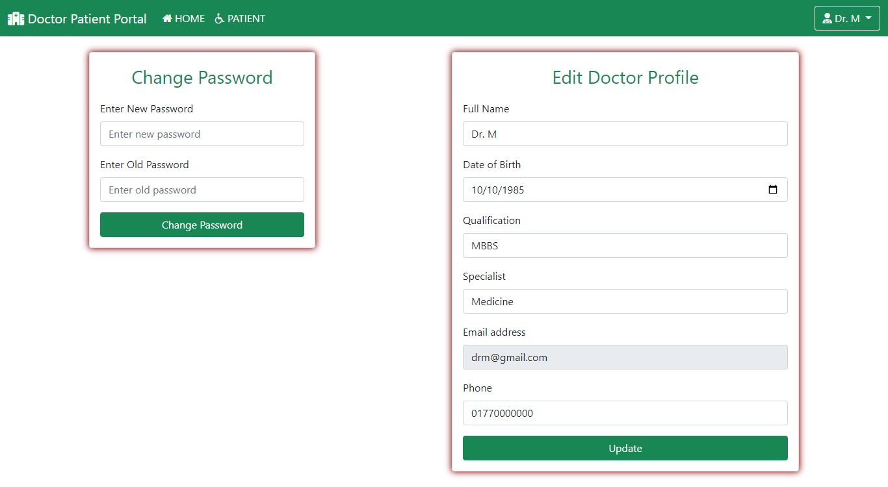](https://user-images.githubusercontent.com/91146041/205283021-531eef60-6da8-417a-9b8d-5554608af19f.png)

**Prescribe medicine / Treatment Comment:**

[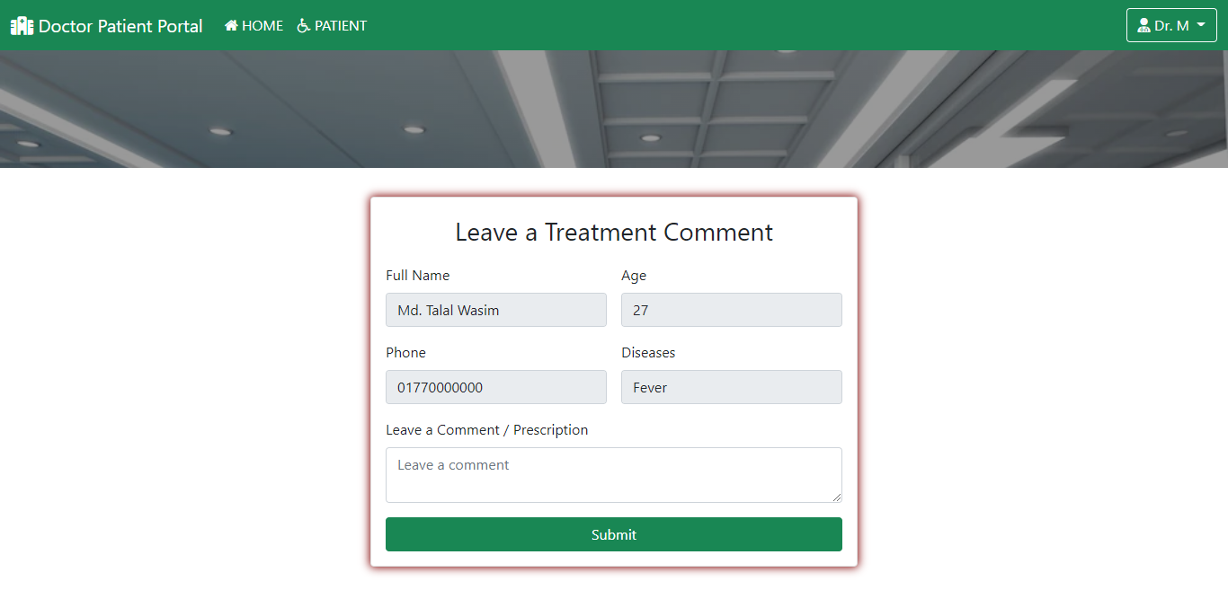](https://user-images.githubusercontent.com/91146041/205283023-b1e52979-6d69-4f4a-afcf-153b93b9d7ba.png)

**User Register first for Appointment Request:**

[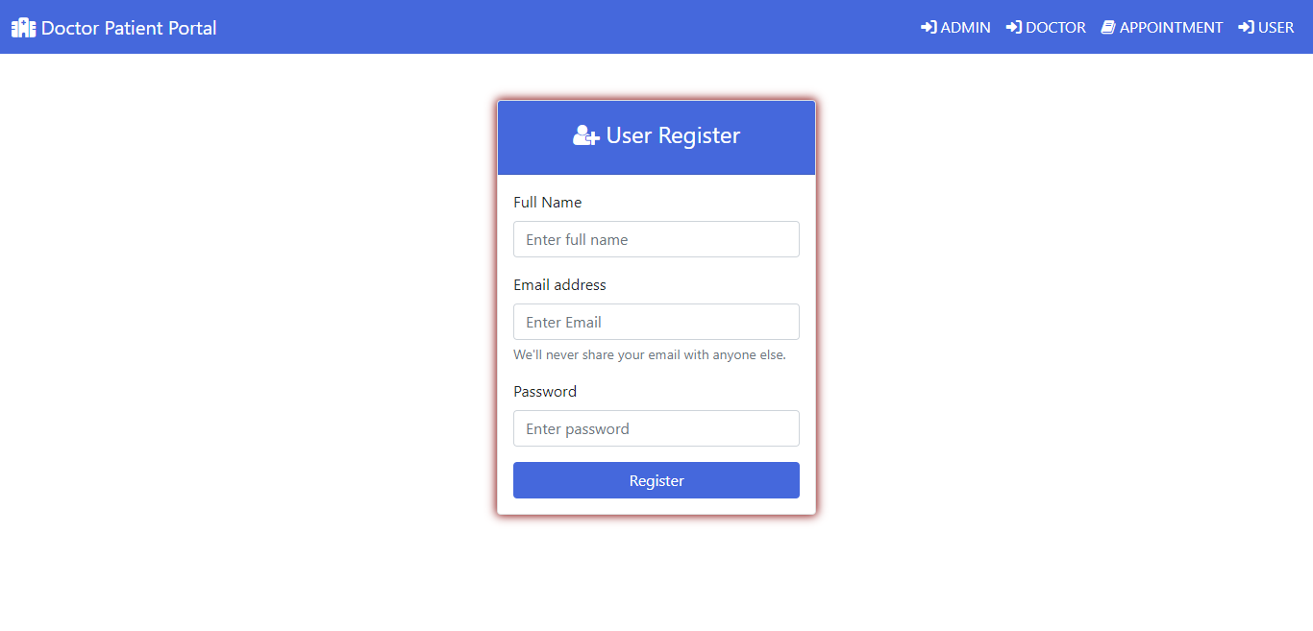](https://user-images.githubusercontent.com/91146041/205283034-196f20f7-c1fd-4ee3-9b04-5e208f89a7d8.png)

**User Login:**

[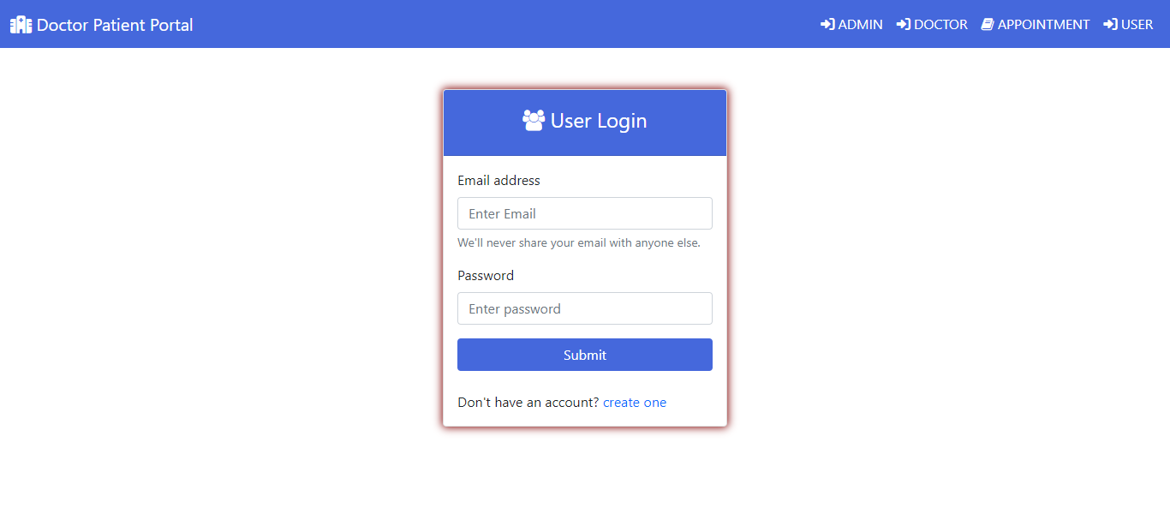](https://user-images.githubusercontent.com/91146041/205283038-1c24b1ad-48e7-452f-8528-8c4609b6b9d6.png)

**User 1 Dashboard:**

[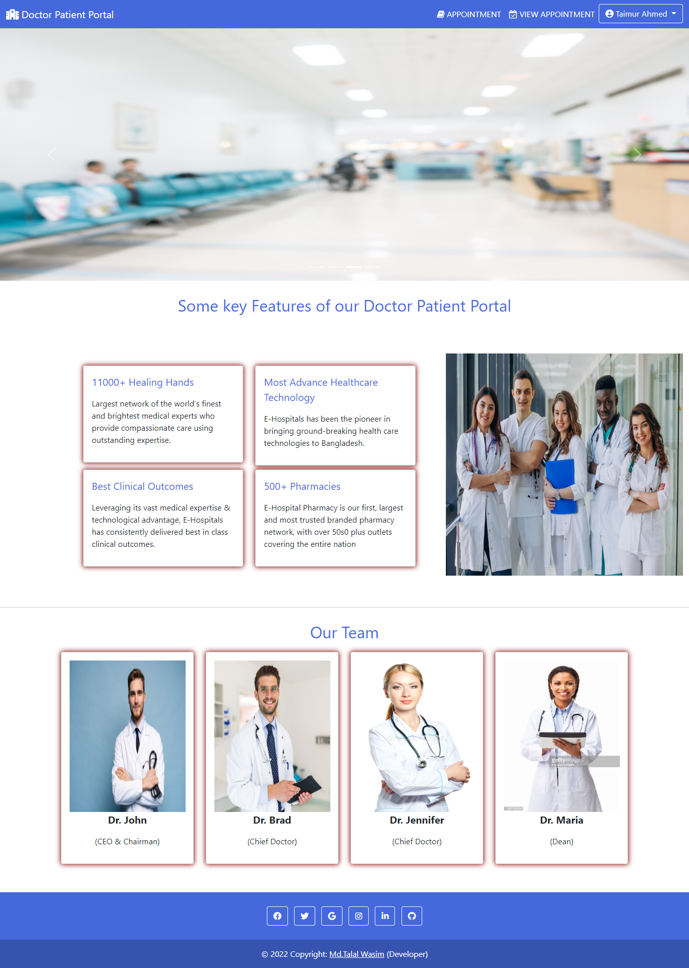](https://user-images.githubusercontent.com/91146041/205283041-23e6d78f-f3e9-4ef7-95e2-000f44344bdf.png)

**User 2 Dashboard:**

[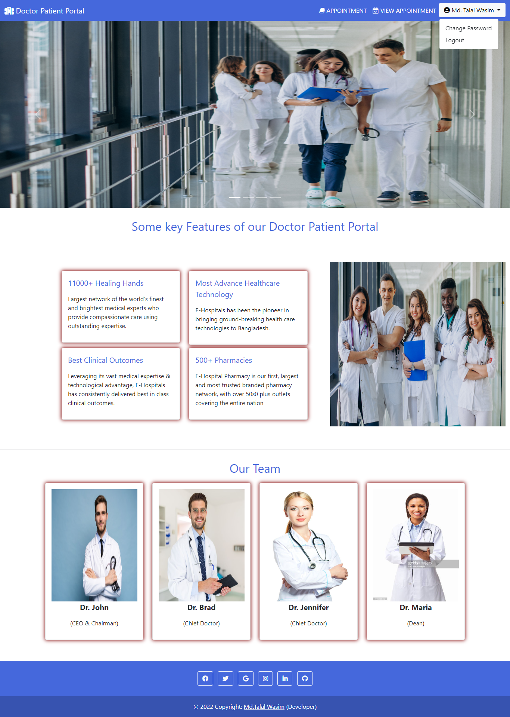](https://user-images.githubusercontent.com/91146041/205283047-6fdc5a37-7da8-4640-90ea-e2768126b58b.png)

**Make Appointment Request:**

[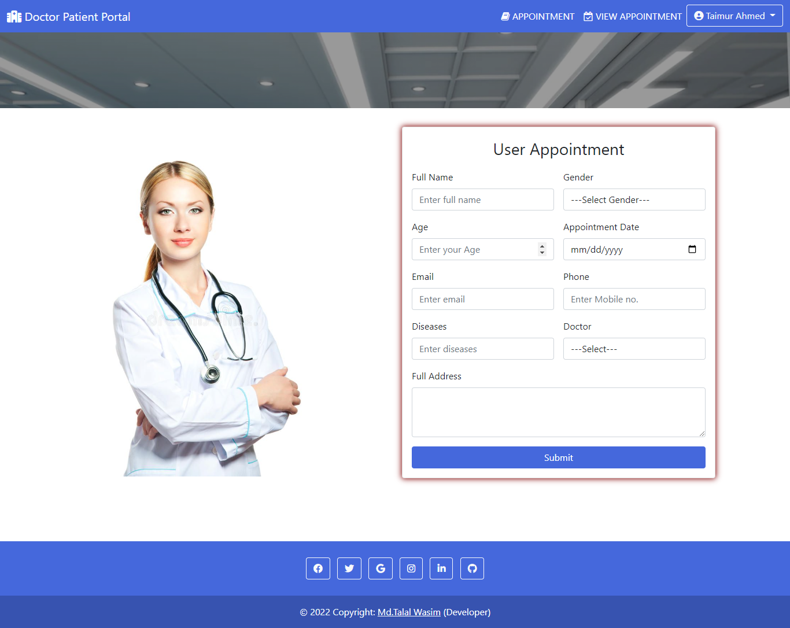](https://user-images.githubusercontent.com/91146041/205283049-bceb5fdb-e686-4d2b-afe3-0a35bbafa1dd.png)

**View list of appointment**

[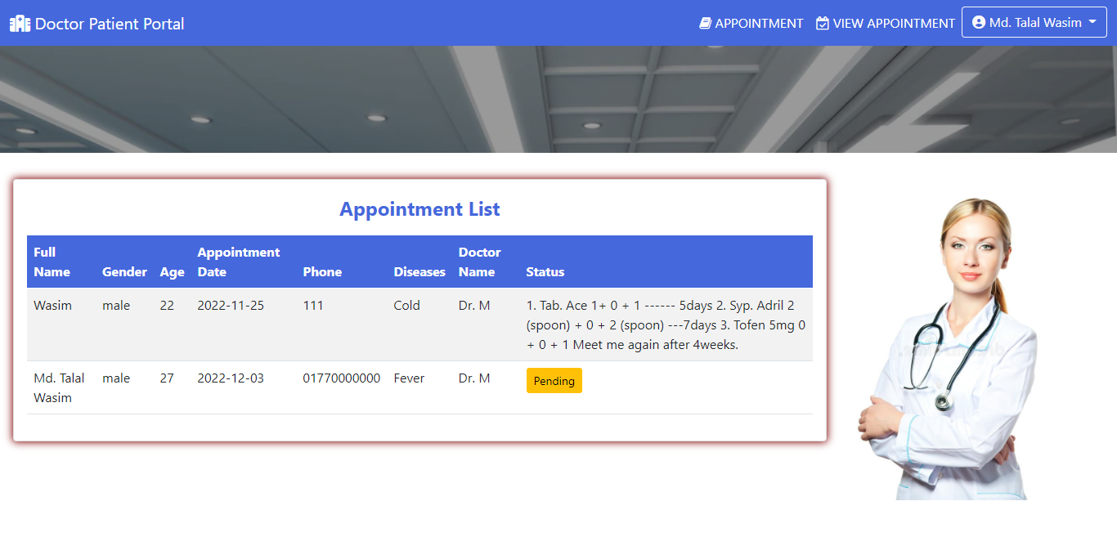](https://user-images.githubusercontent.com/91146041/205283053-6b00959a-a2b1-4285-a040-67e7c1bcbe2c.png)**Syed Mahammad Jasim**